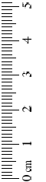
Form 3: PURPLE LOOSESTRIFE biocontrol monitoring (Fall ) Time______ Temperature __________
SITE: ______________________________________
1. Slide the frame into position, as close to the ground as possible.
2. Move stems in or out of frame so that all stems originating in the
quadrat at ground level are included.
3. Estimate and record how much of the quadrat is covered by purple loosestrife and cattail.
4. Count and record the number of loosestrife stems (stems originate at the ground), beginning at one corner and working systematically across the quadrat. If it originates under or outside the frame do not count it. 5. Count and record the number of cattail stems.
6. Count and record number of purple loosestrife and cattail inflorescences in the quadrat.
7. Select the 5 tallest purple loosestrife stems in each quadrat Start with the first stem and do a, b, c, d before moving to the next stem.
- Measure the stem height to the closest cm.
- Count the number of inflorescences on the stem (including all side branches).
- Measure the length of the longest inflorescence on stem (usually the terminal).
- Remove the central 5 cm portion of this inflorescence, and count the number of flower buds in this 5 cm length.
9. Select the 5 tallest cattail stems in each quadrat and measure height, and record if sterile or not.

DATE: _____________________________________

Month/ Day/Year
Supervised by ______________________________
INVESTIGATORS:
__________________________________________
__________________________________________

Weather ___________________________________
(Sunny, overcast, rainy, humid)
Inflorescences: The portion of the stem above and including
the lowest flower bud.
 | Percent Cover (Chart B) |  | Number of stems |  | Number of inflorescences
Quadrat # | Purple loosestrife | Cattail | Purple loosestrife | Cattail | Purple loosestrife | Cattail

Purple Loosestrife (5 tallest stems)
Cattail (5 tallest stems)
Stem | Height (cm) | S= Sterile (no seeds) or F=Fertile (seeds)
1
2
3
4
5

Chart B:
Percent Cover
A | <1%
B | 1-5%
C | 6-25%
D | 26-50%
E | 51-75%
F | 76-95%
G | >95%

stem | Height (cm) | Number of inflorescences | Length (cm) of terminal inflorescence | # of flower buds in center 5 cm of terminal inflorescence
1
2
3
4
5

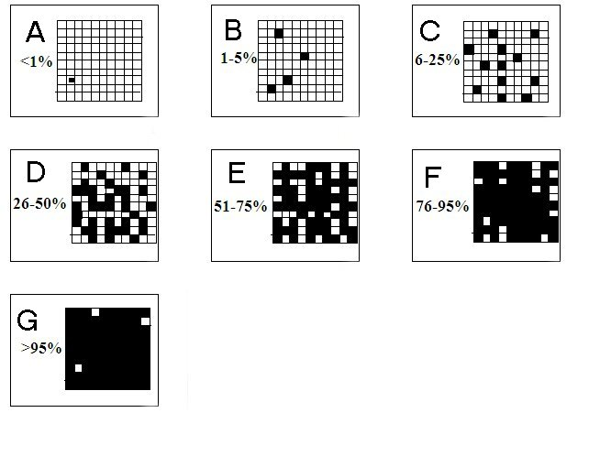
CHART B: PERCENT COVER
Chart B:
Percent Cover
A | <1%
B | 1-5%
C | 6-25%
D | 26-50%
E | 51-75%
F | 76-95%
G | >95%

Checklist:

Materials per team:
_____ meter stick or tape measure
_____ m² quadrat frame
_____ pencils
_____ clipboard
_____ identification field guides

